**video streaming sd youtube, netflix, hotstar**

**Requirement** : how to build a video streaming platform

**Let see some functional and non functional requirement**

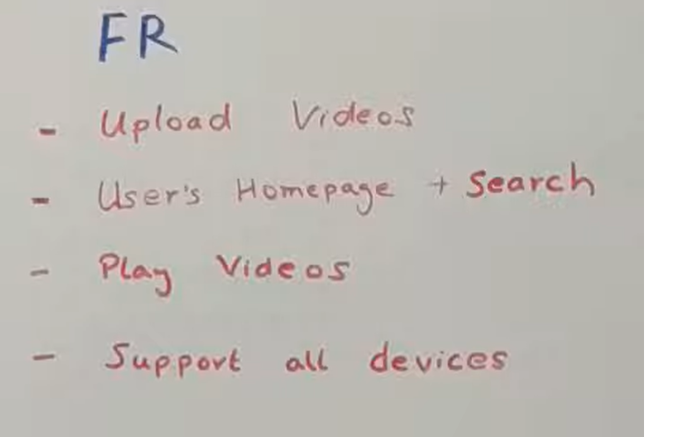

**So**  the very first thing is people should be able to come up and upload video like it could be individual u and me or production houses who are uploading their movies and song . now as a convention all such people who uploading video as **production houses**

**Now**  **user** once they come onto our platform they would have a homepage on which they would see some most viewed videos. So they should be able to see the homepage with some of the recommendation. And they should be able to search for a particular video any movie or anything they want to search.

Now once to see the **search result**  they should be able to play one video whatever they want. So search and play is one of the feature.

Our **platform should support all** devices since user can come from various platform like mobile ,laptop , smart phone on which it is possible to play a video.

**NFR**

**There**  should be **no buffering at all.** What do u means by no buffering .

The video should be available when device want to play which means that the server which is serving the video should be responding in very low latency and should be always available.

The next NFR is to increase **user session time.**

Good  **recommendation**  engine

All of the device should support some specific format and there are some device which are specific to some kind of format. So there are lot of dimension and aspect ratio that are come in since there are multiple phone with different dimension. So each format we have a lot of dimension. Types of bandwidth we have to support(like 1080 px) . lot of version of bandwidth we have to support ( like we can increase or decrease video px)

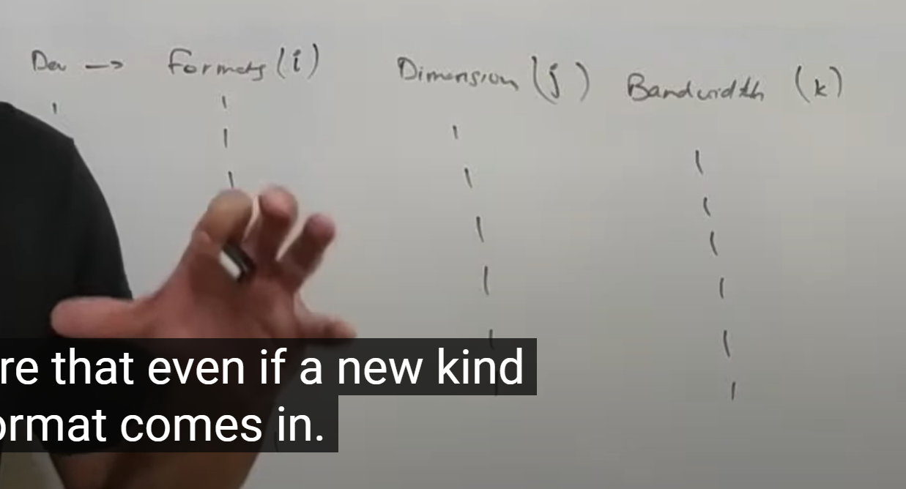

There are i*j*k user which is huge so let look how we handle these user in generic way

Even a new file format comes in so its easy enough for us to handle.

Coming to the user of this platform there are **three consumer** who will be using this platform.

**1 client 2 user 3 production house**

**Client** is basically a device( laptop, mobile phone , smart phone) any device that has video playing functionality.

Second one is **user**  viewing the content on the client. Like viewing the video through mobile phone then I m the user and mobile phone is the client. User :- human being

**Production house** : who uploading the video on platform. It could be individual as well.

**Now lets look how client work**

Client is any device that we are using to play a video.

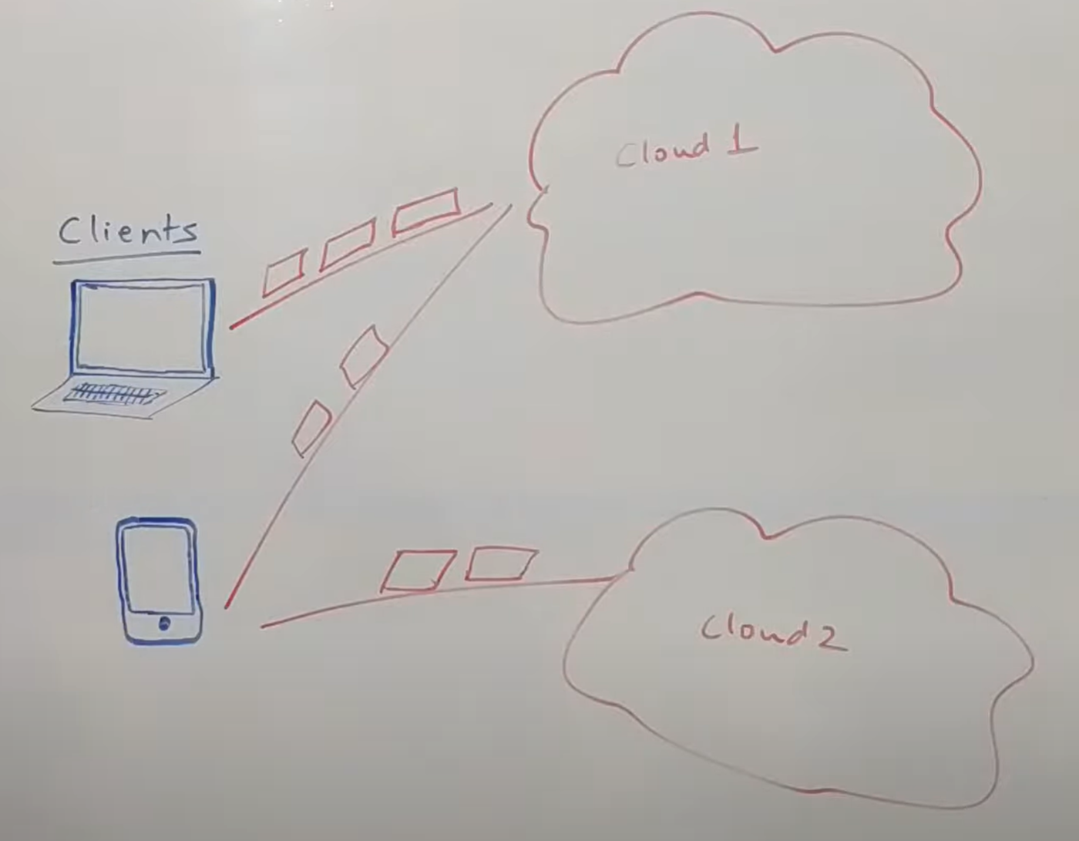

In this ex we have laptop and mobile phone both play video. They don’t download whole file to your device and then start playing. They basically request a chunk of video play that and while that chunk is being played the client request for further chunk. And subsequently each chunks come in that get played and the next chunk are in transit from the server to the client so that’s how it normally work. Now in this example a part of video is played and some chunks are coming. Now **client** is very important functionality. It basically first tries to figure out what devices am I on and what files format can I support. Now let say device support multiple format . now let say it request for a high definition variant of that file format and first chunk get received on the client and it start playing video. Now if the client realizes that subsequent chunk are not coming in time. Let say second , third and fourth chunk are coming very slow. It has not received them and it figures out that it will not be able to get that chunk well in time it basically request a low quality version of that chunk. So let say if we are playing 1080p it probably request for 480 p video. What this does is it basically try to at run time figure out how much bandwidth I have and basics that try to adjust the quality of the video. Now there are libraries to build these functionality. These types of features are there in device because it always good to play high quality video but not at cost of buffering.

**So as much as possible all these clients try to maximize the quality as much as possible but when they are realize that they are not able to get enough bandwidth they move to low quality version**

So this all about **adaptive bitrate streaming**  and client mainly takes cares of which type file to request and how to play the content.

**Now let looks at the overall architecture of the whole system**

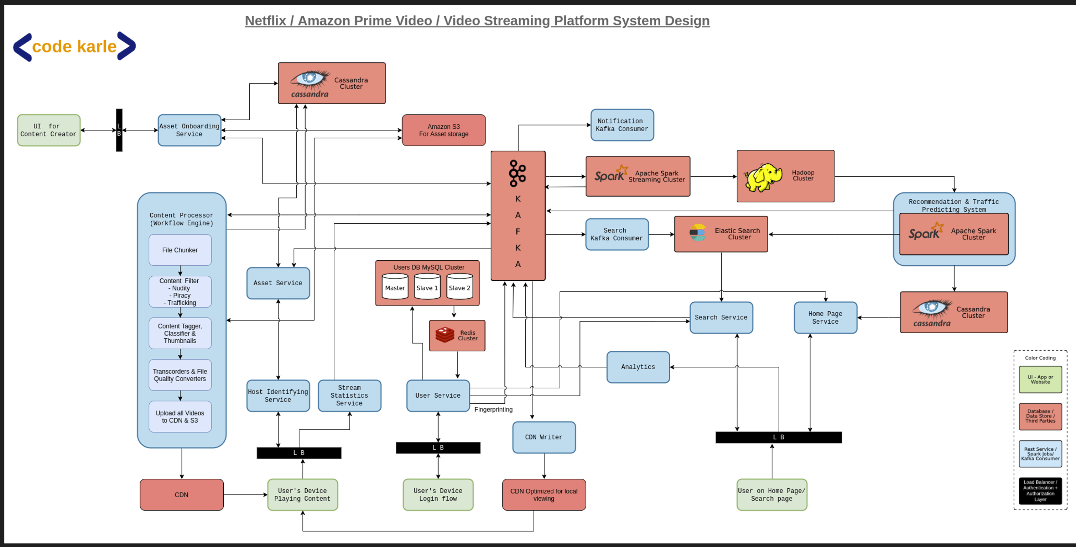

But there are lot of component in this video streaming system

**We will first start set of services that are powering all the tools that are given to the production houses**

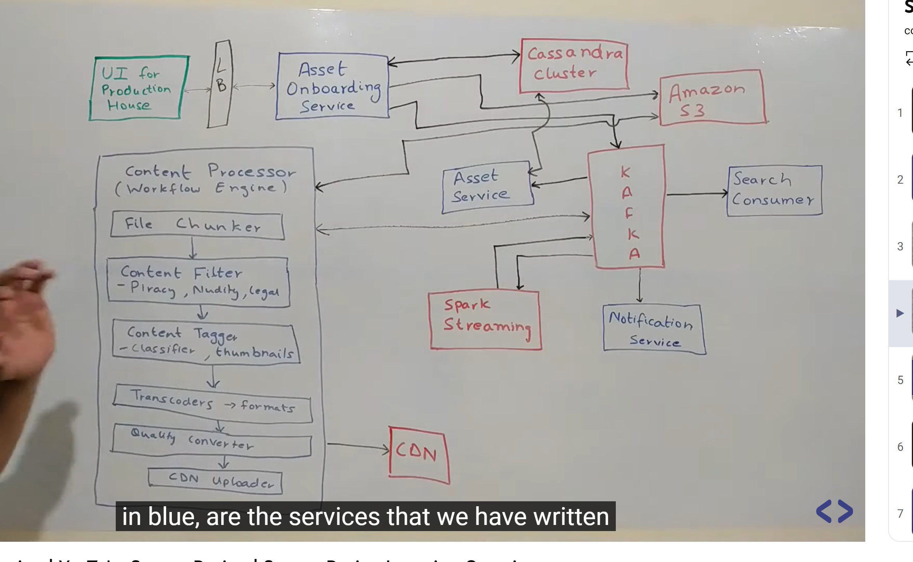

**A bit**  of convention **everything in blue** are the services that we have written. These could be web services , kafka consumer anything that we have build on our own. **Everything in red** is data store or d/b or a cluster or something open source that we have consumed.

**everything in green**  is end consumer . everything in black is load balancer which will authenticates all the api that are coming in from outside world into our system.

**Now lets look how the business flow works**

**Wht does streamed mean in YouTube?**

Live streams let you watch media that's broadcasted in real-time with others from YouTube

**So the**  very first step for the whole flow is somebody coming into this UI and uploading a content. Now there are multiple ways in which content can be uploaded. For a small video there could be upload button where somebody uploading the files from their own disk. **But for movies that is practically not possible**. So for the raw files that production house would gives out for a movie would easily be 20gb, 30 gb or may be 40 gb big. These are the most highest definition content with a good audio quality and all of that and then there will be later transcoded into diff kind of format so that has a lot of information therefore very big size. Upload doesn’t make too much sense there. So ideally the way it would probably work they would have SFTP server running somewhere on their side wherein the content would be present they would just give a link to sftp server some user name and password and let us do all the work.

So assuming that how it is done the UI for **production houses**  **will**  talk to **asset onboarding services**  give it to URL and asset onboarding service would call up where content is hosted may be another s3 bucket may be some sftp server pull the content and put it into own s3. We are using Cassandra as a datastore which contain all the information about all the videos . so it has some information who is uploading it

So what **asset onboarding service** does is it start pulling from the source upload it into s3 once the file is in our amazon s3 then there are lot of step that we need to do.

Asset onboarding service would send out an event into **kafka**  saying I have taken the file now whoever wants to do whatever go do your job so there are parts on asset onboarding service end and it sends an event into kafka. Now there are lot of consumer that are sitting on this kafka. One of the consumer is **content processor :**  think like a workflow engine which does a lot of of things to do that file that are uploaded for it to ab available in various kind of format various bandwidth requirement all all of that we talked earlier. So coming to what this does first of all we talked about while the video is streamed . it will never be streamed as a single file. There will be a chunk that the video would be divided in. and all of the processing that is done on the video would also be done in chunk. **So the very first thing that happens to file**  it  goes to a **file chunker** which  divides it into multiple segment. It could be size based segment , time based segment or any random method of segmenting. Now this content processor also uses kafka to send out various event and to invoke the further processes. What it does is for each of these sub segment it calls a **content filter which**  does is so in each video platform there are certain there are certain kind of thing that are not allowed. There are certain check that need to happen so **piracy is**  one of the first thing. And now all of those check that can parallelly happen on individual component( chunk) instead of looking at one big file. Once content filter goes through it sent out event saying I m done now whoever next can go and pick it up. The next thing is **content tagger.**  What it does let say there is video uploaded now production house will give some tag which can be searched . it tries to create thumbnail of video so across the whole video stream it tries to figure out some screen which are good and it creates a list of thumbnail that would later be used for AB testing and trying to figure out which out of the thumbnail are actually the best ones and those would be uses thumnail for the later and for the whole video. At a later point in time.

What is meant by thumbnail image?

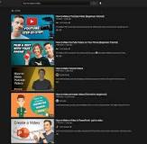

A thumbnail was **a smaller version of a full digital image that could easily be viewed while browsing a number of images**.

Now post content tagger state we have something called a **transcoder.**  Transcoding is basically an activity of converting one file into another file type. So the raw video that was uploaded whose chunk we are processing those would be converted into multiple file format like avi , mp4 so think like that each file(chunk) will be split into multiple sub files (sub chunk) now each of these format that we have will be sent out for individual transformation next. Next thing is **quality converter. So**  we might want to have multiple format which require different bandwidth. So each of those format will now be converted into multiple format basis the bandwidth we have.once all of that is done then we basically upload individual component( chunks) onto the CDN so this is file processing cycle. And even while all these happening all of the events are put into kafka. But kafka is not just use for invoking the further processor so lets say content tagger tags each chunk with a certain tag all of this information could be put into kafka now there could be a **spark streaming process** that runs across all the chunk for a particular movie id and keep aggregating all the tags that are received but at the end it aggregated at one point in time. Now post this the work of **content processor** is complete when it uploaded all the chunk on the **CDN.**  So this is one of the CDN that we are using which have all the information. There are more CDN that we will talk about as we proceed. Now when all of that done, upload into CDN complete it will send out an event into kafka. There will be an **asset service**  **that**  will be reading all of those event because somewhere we need to keep track what is happening with the whole movie. How many chunk are there which chunk in which status so all of that is handled by asset service and it is storing all the information about all the chunk into cassandra. Now once it identified( asset service) that everything is complete and all the chunks have been processed completely it will sedn out a **notification**  through again routing through kafka via **notification service to**  the person who has actually uploaded the image saying your movies is now processed because this process in not something which will be completed in second. So the person will give a URL from this ui click a submit button and go away. So other than notification there are lot other consumers that are also running on this kafka . **search consumer is one of them**

**Now let talk about the services that are powering user facing products.**

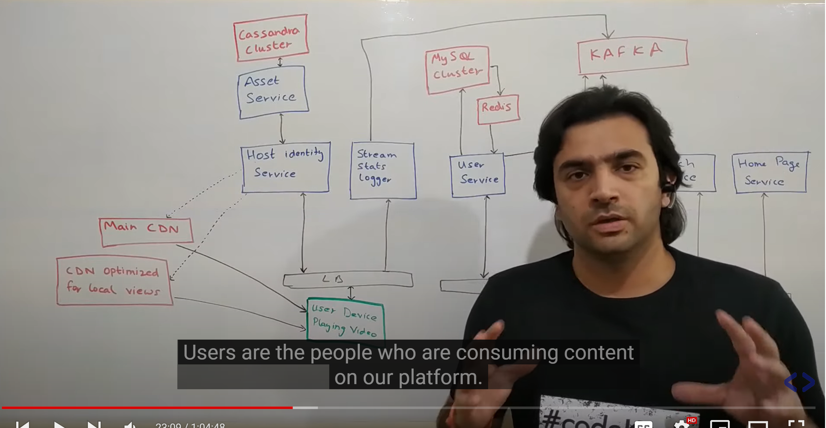

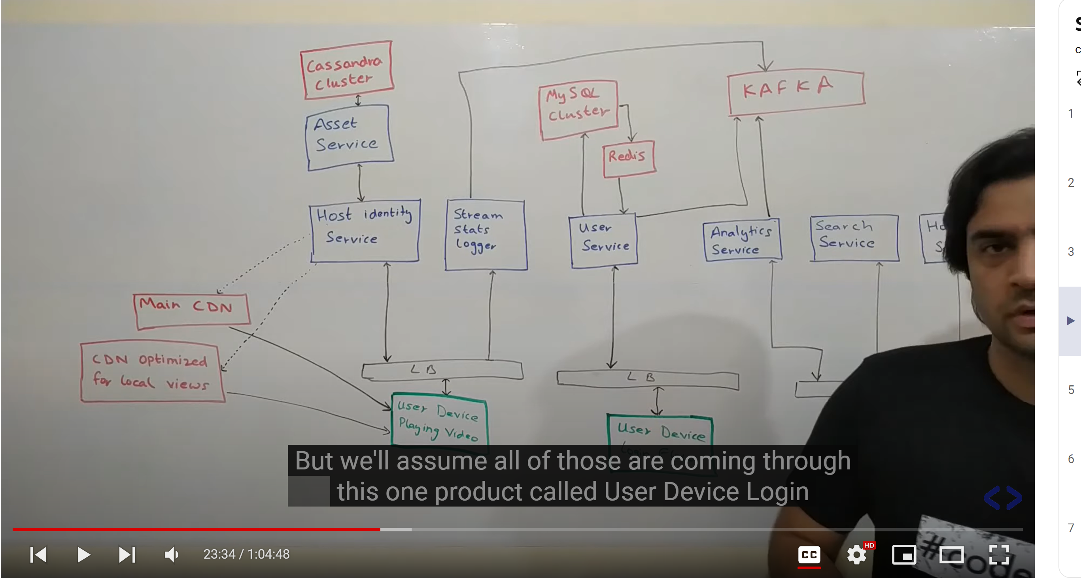

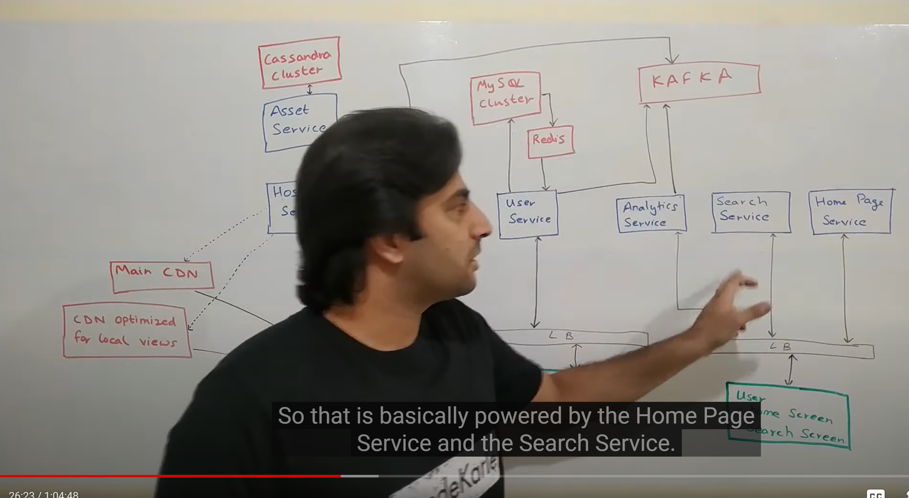

**User:**  are the people who are consuming content on our platform so one of the very first interaction that we have with the user is when they try to login. And this login could be happen from bunch of client could be from a mobile application , smart tv , web browser but we assume all of those are coming through the one product called **user device login**  which talks to **user service** internally for authentication. Now the responsibility of user service is to be the source of truth of all user related information. This user service sit on the top of mysql d/b which has all the information of user like name , email address , contact information , country they are coming from . it could also have information about subscription. Now it (user service) uses **redis** as a cache .now lot of other service in the ecosystem call user service to get information about a particular user. User service could potentially called mysql all the time for all the request but that’s but probably not an efficient choice. We might as well cache the user information because that is not changing very frequently. For caching we will using redis where the key would be user id and the value would be payload of user information.

Example : so probably **search service would call user service**  to get user information so that they can filter out certain result so some search result would have an age restriction for example so some search result would be applicatble in certain countries so for all of that information user service becomes the source of truth. So that’s mainly about user service. It do one more thing if same account is logged in from different account and from different geographies it probably means either the person is travelling a lot or the credentials have been shared with others.

So the next thing user does after login is basically get to see a **home screen**  **and**  on the home screen they should be able to search something. So that is basically powered by **home page service and search service.**

Home page service is the one that gives out data that would be rendered as soon as the person has logged in which is the first screen that the person sees. And if they are searching something that would be powered by **search service . functioning**  of both these service will probably look into next section but basis the result of these two service we would probably want to do some analytics on top of it. So let say we have some ui like youtube or netflix where you see some category and some video into those category and let say if our analytics say there are lot of people are actually going on that video and not clicking on the video that are shown in first page that means there is something wrong in the first **home page service** and it is not returning the best possible result to the user and that need some improvement. The same thing could be said about **search service**  if let say it a paginated result and lot of people are going to page no 2 and page no 3 that means service is probably not returning the best possible result for the user at this point in time. But for this to know how many number of people going to page no 2 without clicking page no 1 we should have data and all of that would be done by this **analytic service. So**  this is basically a user activity analytics service which get feed from various action done by user on the app or website or any client and it sends it to kafka and basis that there could be some kind of analytics that we could do which will then be use to improve the search result and the recommendation engine and all of those thing. **Now let say a person has done some search and they have got to a video and they want to play it. they would probably click on that get to a screen click on play button and they expect the screen to start playing. Now how that does work**

That actually follows this flow which is basically I m abstracting this thing it a **user device**  playing video flow what that does is it basically make a call to this load balancer to this **host identity service . now**  all of that information about a video, its CDN all of that lies within this CDN cluster on which this **Asset service**  sit which we looked at in previous section. Now this host identity service knows what video you want to play and where u r coming from . it will query asset service to get me all the cdn that are available with this video. And given the location of the user and the location of all the videos that are there it will try to come up with one of the CDN that is responsible to play this particular video. So that’s the main responsibility of this **host identity service.**  **Now this service could return two types of CDN.**

**One**  I m calling main CDN which is basically a repository of all the videos that we have.

There is another CDN that we have which I m calling CDN optimized for local views. But it is basically a CDN which is geographically centric. So let just say we have two CDN server like we talked about one in US one in Germany and a user is coming from us itself. So they will be redirected to main CDN but let say there is a user coming from india normally let say if Germany is close by they would get the CDN of Germany to talk to but for some reason let just say we have enough analytics and we get to know that people in india are watching a particular video a lot we could actually host a cdn service in india and upload that video in that CDN. Now all the people asking for that particular video from india would be given the local CDN to talk because that help us to save lot of traffic network..

Now as a client playing a particular video there are lot of information that we can capture about this interaction of a person viewing a video. Like if people watching completed video then video is good these are some analytics we can capture. And all of that is done by **stream stats logger service**  which basically get pings once in a while that a person has watched this video till this point in time and that again get pushed into kafka. And that can again be used to do some analytics mainly to come up with a rating for a particular video.

**Now let look at the remaining pieces of the architecture and how it all come together.**

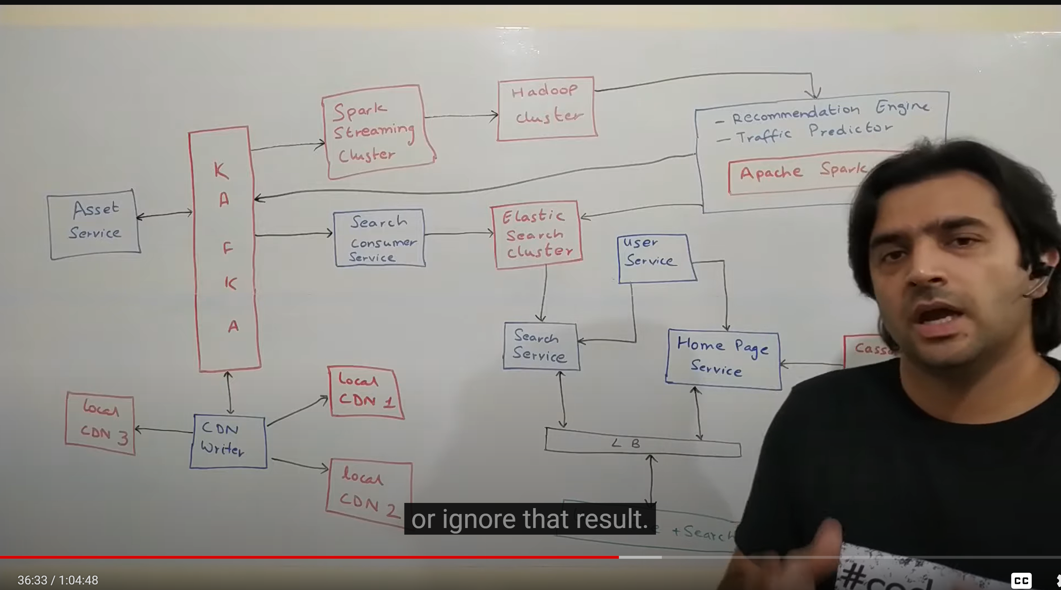

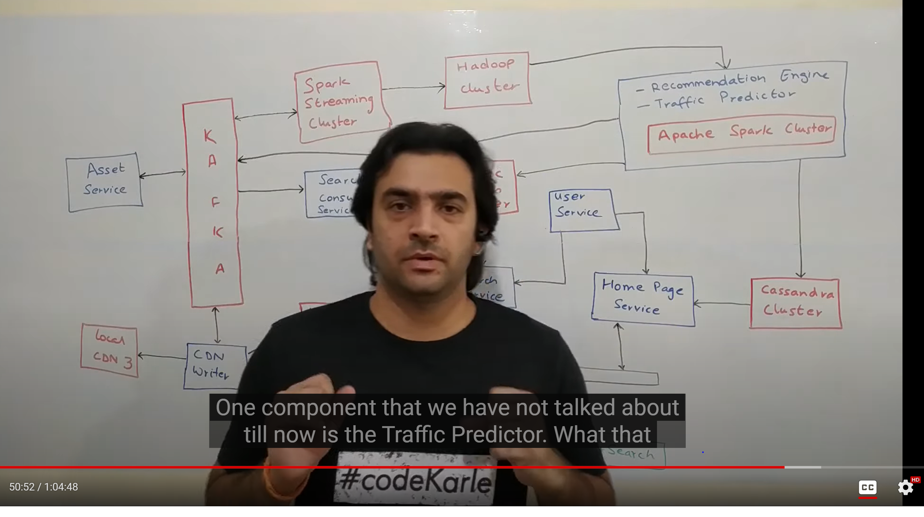

More imp in the previous two section we had put a lot of events into kafka of various types.

Now we will try to understand how each of these event is helping us and what information can we extract out of it and how it will help us to enhance our whole system.

So one of the event that **asset service**  **publishes is the on boarding of a new video.**

Once a new video come it divided into chunk and it uploaded into CDN and once the whole process is completed Asset service pushes an event into kafka saying now the video is ready. What that means is now the video is ready for consumer to see it. And how the consumer see it only when it pops up either in their home page or in search result so essentially what we need to do is make this video available for searches. So that the event that was pushed into kafka would have a lot of information about the whole movie. So there

Will be a **search consumer service**  which will be listening to the topic where that event was published it will pick up that event it will convert that event in a format that it wants to. It can filter using age and so on and post all of the data massaging that it has to do it will put it in its **data store.**  Now we are using elastic search here. It help in **fuzzy search**. So this is basically injestion into elastic search flow.

**Now on the other side when the user is actually trying to search** **a movie** what he will do he will follow this flow where they will come to their home screen type something in search box it come through this load balancer to **search service**  the schema is shared between search service and search consumer so both of them understand what data is within elastic search and how it is maintained and what field means what. So it would be able to search for that particular string on all the fields that are important enough. And this particular piece would be taken care by search service. Now let say search service get some response from elastic search and it get to know that there is particular flag which says that I need to do an age level filtering on the user who searching for what then it will be possible . it will query the user service and get the information of the particular user. And basis the information it get from user service it might choose to show that result or ignore that result. And at the end after doing this whole data massaging it can respond back to the UI with search result which can then displayed to the user. **So this is the search flow.**  All are horizontally scalable.

Coming back to content tagger let say there are 1000 of chunk which are individually being processed and all of information about tags in each chunk is being put into kafka.

**Now lets try to understand how would that get aggregated and how would be that** stored back again.

Assuming that information again comes into kafka . there will be spark streaming cluster running which will be listening on to the topics where all tag related information is being passed through. That information would be a movie id tag information like tag name and probably a chunk id and some additional information like how many chunk are there so that it is able to identify everything is processed. Now what it will do it will keep polling all the information so this cluster just in itself should be good enough to identify that given a movie and about all the chunks and their tags which are top 5 or top 10 in tags in that movie . it could then send back the same information to kafka which could then read by **asset service which**  could then persisted back in the Cassandra data store that it uses. So that was one more event that we covered. Cassandra consist of lot node and each node have some part of data and each node know what kind of data is there. So if we want to handle more amount of data all we need to do to add more more node in Cassandra cluster.

Cassandra is really good when we have small number of (distinct type of) queries and a query is by something called partition key. Queries like give me all the chunk of particular movie or give me all information about particular chunk. **It is really** **bad** when we want to do random queries. Cassnadra is also bad at doing aggregation. For that we have Hadoop cluster.

**Other than tagging by content tagger It will also show lot of thumbnail images so how it will do that**

**A**ssuming all those information again come into kafka saying for a movie id some id a lot of thumbnails generated. They will be generated for individual pieces and then that could be aggregated. So that is one part of the story. Assuming all those information comes to this spark cluster and then it get stored into **Hadoop cluster** now the next side of thing . when the search result shown to the user randomnly some of the thumbnail would be shown to some of the user. What we could now do is remember the user side of thing where we had a home screen service and a search service and an analytic service . analytic service sending out various event into kafka about the performance of search result and the result of home page service. This could also bring us information about which thumbnail work best. So let say there are particular thumbnail on which we get a lot of click are certain thumbnail on which we do not get a lot of click now **both these information of all the thumbnail and the performance of each thumbnail**  would be join together to figure out which thumbnail is the best one for a movie and that thumbnail should be shown. So this is one of way in which we could figure out best thumbnail. Now we can take one step further. I do have that data in Hadoop of all the thumbnails. We will put data of analytics service also in Hadoop saying I have a log of which thumbnail got what kind of views for what kind of users. Now instead of finding just one best thumbnail we could run our machine learning model on this whick kind of of user which thumbnails work the best.

**We were also putting lot of information into kafka about the videos that a person is watching**

**What**  percentage of video is watching let user watch for short time then we can assume person is not liking a video but we can use this time duration as a proxy for rating . let we precalculate like user 1 , user 2 ,user 3 like MI movie and store it into Cassandra saying a user is likely to watch these set of movies so when we are building home page of user try to put that movie into that.

**Another event that coming into kafka was the geo tagging and the device finger printing**  of users at the time of logging . put that into spark streaming put that into Hadoop, do a group by kind of a thing by user_id try to figure out how many unique login have come in for users.

Now one component that we have not talked till now is the **traffic predictor.**

**There**  are multiple way to load data into local CDN. Again it would be machine learning model that uses all of the usage data like what videos people are watching.

It will do analysis and saying that for tomorrow in these CDN we have those videos.

And then it will put event into kafka saying this is my report of what I believe is required tomorrow go make sure it is available. There is something called **CDN writer :**  it basically look at those event and fetches all the videos and put them in the right place. It could fetch from amazon s3 or it could fetch from main CDN and put his in the required CDN.

Remember : in any system design we should never have single point of failure

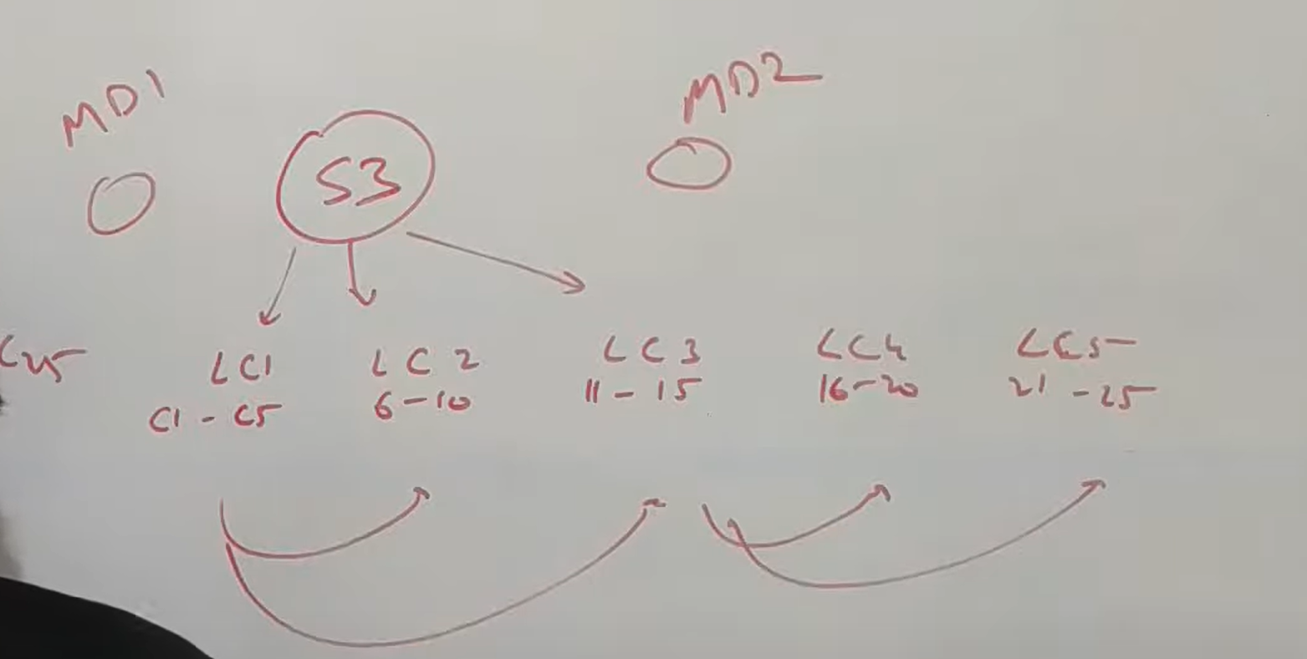

Local cdn main cdn : so this is how we could do efficiently using CDN

**Now let see optimization :**

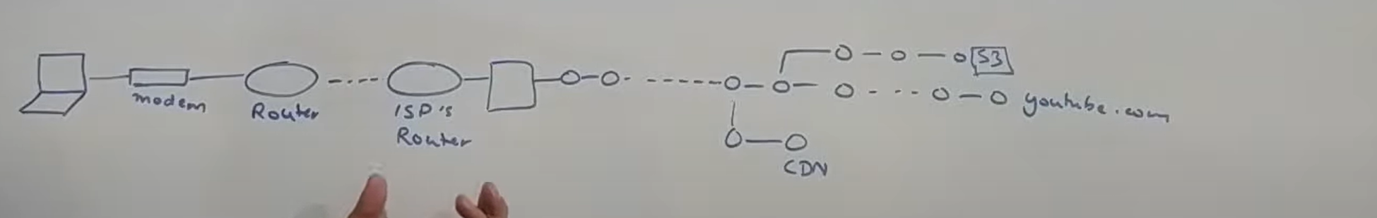

**No**w let say there are multiple user search same video and local CDN providing it. This is wasted of resource for both ISP and the service provider. For service provider because if there are too much traffic they have to add number of nodes.if the same isp is requesting same video again and again they are basically sending the same data to the ISP but still they have to add more node because traffic is increasing. For isp they to pay as much as they use the bandwidth. So the more they have to query some external service the more they have to pay for the bandwidth. So as part of optimization they will try to add a node kind of add a hard disk so some content which is being requested very frequently they try to cache it over so next time when fourth query goes there it will respond back from the hard disk.

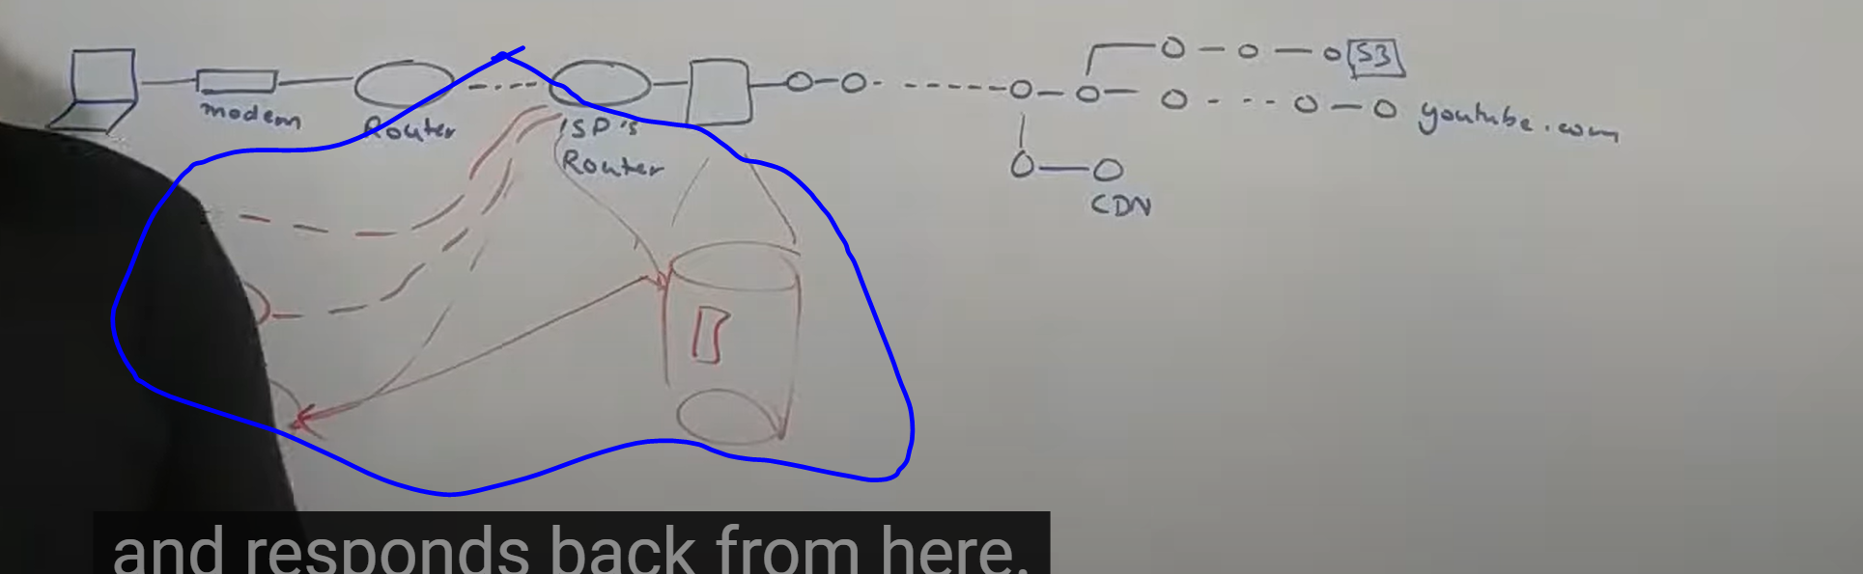

Now in case of Netflix the gave h/w to isp from CDN and Netflix will maintain so for isp it is free and it will cache the information there.

It saving lot of NFR extremely low latency. Now for Netflix this h/w is open connect

[Netflix | Open Connect](https://openconnect.netflix.com/)

[https://openconnect.netflix.com](https://openconnect.netflix.com/)

The Netflix **Open Connect** program provides opportunities for ISP partners to improve their customers' Netflix user experience by localizing Netflix traffic and ..